Personalized Learning with Generative AI and LMS Integration
Project Title: Personalized Learning with Generative AI and LMS Integration

Team Information
Team ID: LTVIP2025TMID21204
Team Size: 4
Team Leader: Yeduruvada Nithya Sri
Team Member: Visingiri Akhil kumar
Team Member:Vutla venu sri
Team Member: Yerramsetty mohan pavan manikanta
Table of Contents
- Project Overview
- System Architecture
- Technology Stack
- Project Structure
- Implementation Details
- Development Workflow
- Setup and Installation
- Features and Functionality
- API Documentation
- Screenshots and Results
- Challenges and Solutions
- Future Enhancements
- Conclusion
1. Project Overview
1.1 Problem Statement
- 1. Lack of Personalization in Traditional Learning Systems:
- Most existing LMS platforms deliver generic content that does not cater to individual learning styles, pace, or preferences.
- 2. Overwhelming Amount of Learning Material:
- Learners struggle to find relevant content suited to their current knowledge level and career goals, leading to inefficient learning paths.
- 3. Limited Adaptive Feedback
- Traditional LMSs lack the capability to dynamically generate personalized feedback or content based on real-time performance and learning behavior.
- 4. Underutilization of Learning Data:
- Learning Management Systems generate vast amounts of data but fail to leverage it for tailoring educational experiences.
- 5. Static Course Structures:
- Courses are rigid and not responsive to learners’ evolving strengths, weaknesses, and interests.

1.3 Target Audience Impact
- 1. Students and Learners of All Levels – To provide a personalized learning journey suited to each learner’s pace, interest, and understanding.
- 2. Educators and Institutions – To assist in managing adaptive content delivery and monitoring student progress automatically1. Use of Generative AI
- To analyze student behavior, learning patterns, and performance, then generate custom content or feedback2. Integration with LMS Platforms
- Seamless connection with LMS systems to track learner activity, store progress, and deliver AI-generated content.
1.4 Proposed Solution
1.4.1 Introduction
- 1. Modern Education Faces a Personalization Gap
- Most digital learning environments lack the ability to adapt content based on individual learner needs.
- 2. 💻 Learning Management Systems (LMS) Are Static
1.4.2 Objectives
- Primary Goal:To Develop a Personalized Learning System
- Secondary Goals:
- To Analyze Learner Behavior Patterns
- To Generate Adaptive Assessments
- To Enable Continuous Feedback Mechanisms
- To Integrate Multi-Format Content
1.4.3 Key Features
. 🧠 Real-Time Learner Behavior Analysis
📝 Adaptive Assessments & Quizzes
. 💬 Instant AI-Powered Feedback
. 📊 Dashboard for Instructors and Students
. 🗃️ Seamless LMS Integration
. 🗣️ Multi-Format Content Generation
. 🧭 Adaptive Learning Paths
. 🔐 Data Privacy and Ethical AI Usage
. 🌐 Scalable and Cloud-Based
2. System Architecture
2.1 Architecture Overview
- Web/mobile portal for students to access personalized content, take assessments, and receive feedback.
- Interactive UI for real-time engagement and tracking progress.
- LMS Platform (Learning Management System)
- Core platform to manage course modules, student records, learning materials, and schedules.
- Acts as the delivery hub for content generated by the AI system.

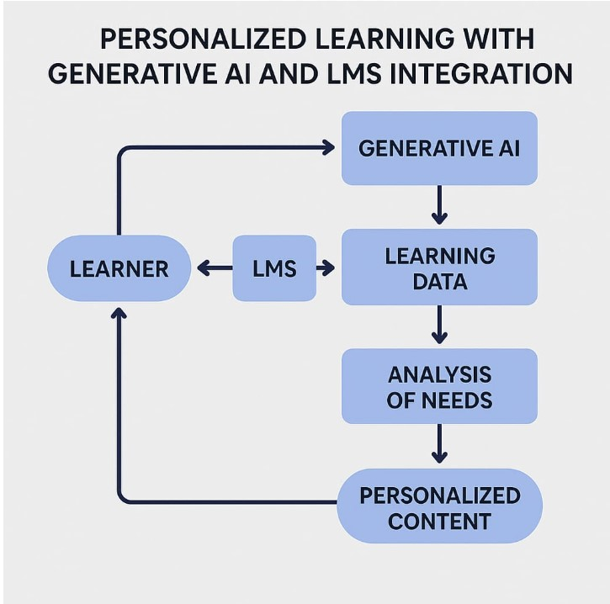
2.2 Component Interaction Flow
📚 Learning Management System (LMS)
📊 Learning Data
🤖 Generative AI Module
📈 Analysis of Needs
3. Technology Stack
3.1 Backend Technologies
- FastAPI: Modern web framework for building APIs
- Python 3.8+: Core programming language
- Pydantic: Data validation and settings management
- Uvicorn: ASGI server for FastAPI
3.2 Frontend Technologies
- Streamlit: Interactive web application framework
- Streamlit-Option-Menu: Enhanced navigation components
- Custom CSS: Styling and UI enhancements
3.3 AI and ML Technologies
- IBM Watsonx: Enterprise-grade AI platform
- Granite LLM: Large language model for text generation
- Sentence Transformers: Text embedding generation
- Scikit-learn: Machine learning algorithms
- Pandas: Data manipulation and analysis
3.4 Database and Storage
- Pinecone: Vector database for semantic search
- File System: Local storage for documents and data
- In-Memory Storage: Session-based data management
4. Project Structure
4.1 Directory Organization
sustainable-smart-city-assistant/
├── app/ # Backend application
│ ├── __init__.py
│ ├── main.py # FastAPI main application
│ ├── api/ # API route handlers
│ │ ├── chat_router.py
│ │ ├── feedback_router.py
│ │ ├── eco_tips_router.py
│ │ ├── kpi_upload_router.py
│ │ ├── vector_router.py
│ │ ├── policy_router.py
│ │ └── dashboard_router.py
│ ├── core/ # Core configurations
│ │ └── config.py
│ └── services/ # Business logic services
│ ├── granite_llm.py
│ ├── pinecone_client.py
│ ├── document_embedder.py
│ ├── document_retriever.py
│ ├── kpi_file_forecaster.py
│ └── anomaly_file_checker.py
├── frontend/ # Frontend application
│ ├── smart_dashboard.py # Main Streamlit app
│ └── components/ # UI components
│ ├── summary_card.py
│ ├── chat_assistant.py
│ ├── feedback_form.py
│ ├── eco_tips.py
│ ├── policy_summarizer.py
│ └── report_generator.py
├── utils/ # Utility functions
├── data/ # Sample data files
├── .env # Environment variables
├── requirements.txt # Dependencies
└── run_app.py # Application launcher
4.2 Key Configuration Files
Environment Configuration (.env)
# IBM Watsonx Configuration
WATSONX_API_KEY=your_ibm_api_key_here
WATSONX_PROJECT_ID=your_project_id_here
WATSONX_URL=https://us-south.ml.cloud.ibm.com
WATSONX_MODEL_ID=ibm/granite-13b-instruct-v2

# Pinecone Configuration
PINECONE_API_KEY=your_pinecone_api_key_here
PINECONE_ENV=your_pinecone_environment
INDEX_NAME=smartcity-policies

# Application Settings
DEBUG=True
API_HOST=127.0.0.1
API_PORT=8000
FRONTEND_PORT=8501

5. Implementation Details
5.1 Backend Implementation
5.1.1 FastAPI Main Application
The main application (app/main.py) serves as the entry point for all API requests:
- Configures CORS middleware for cross-origin requests
- Includes all router modules for modular organization
- Provides health check endpoints
- Handles error responses and logging
5.1.2 IBM Watsonx Integration
The granite_llm.py service handles all interactions with IBM Watsonx:
- Authentication: Secure API key management
- Text Generation: Multiple specialized functions for different use cases
- Error Handling: Robust error management with fallbacks
- Response Processing: Clean formatting of AI responses
Key Functions:
- ask_granite(): General chat functionality
- generate_summary(): Policy document summarization
- generate_eco_tip(): Environmental recommendations
- generate_city_report(): Comprehensive sustainability reports
5.1.3 Vector Database Integration
The pinecone_client.py manages semantic search capabilities:
- Index Management: Automatic index creation and configuration
- Vector Operations: Upsert and query operations
- Embedding Integration: Works with sentence-transformers
- Error Recovery: Handles connection issues gracefully
5.2 Frontend Implementation
5.2.1 Main Dashboard
The smart_dashboard.py serves as the central hub:
- Navigation System: Sidebar with option menu for page routing
- Responsive Design: Optimized for different screen sizes
- Custom Styling: CSS enhancements for professional appearance
- State Management: Session state handling for user interactions
5.2.2 Component Architecture
Each UI component is modularized for reusability:
- Summary Cards: Styled KPI display components
- Chat Interface: Real-time conversation handling
- Forms: User input collection and validation
Data Visualization: Charts and metrics display

6. Development Workflow
6.1 Phase-by-Phase Development
Phase 1: Project Initialization
Objectives Completed:
- Created modular folder structure
- Implemented environment configuration
- Set up dependency management
- Established coding standards
Key Deliverables:
- Project structure with clear separation of concerns
- Configuration management system
- Development environment setup

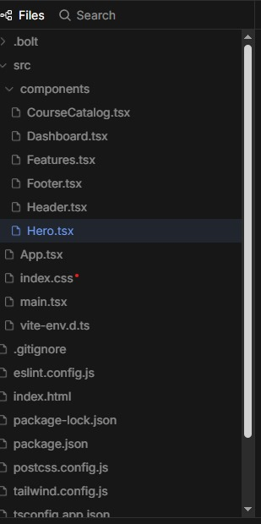Phase 2: IBM Watsonx Integration
Objectives Completed:
- Configured Watsonx API credentials
- Implemented LLM service wrapper
- Created specialized AI functions
- Tested endpoint connectivity
Key Deliverables:
- Granite LLM service implementation
- API testing and validation
- Error handling mechanisms
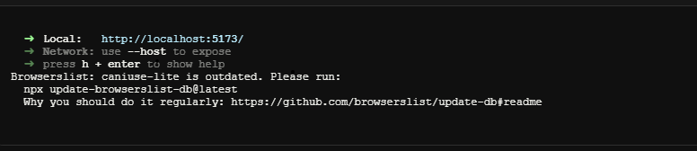
Phase 3: Backend API Development
Objectives Completed:
- Developed modular router architecture
- Implemented RESTful API endpoints
- Added request/response validation
- Created Swagger documentation
Key Deliverables:
- 8 comprehensive API routers
- Input validation and error handling
- Auto-generated API documentation
Phase 4: Frontend UI Design
Objectives Completed:
- Built responsive Streamlit interface
- Created reusable UI components
- Implemented custom styling
- Added interactive navigation
Key Deliverables:
- Professional dashboard interface
- Component-based architecture
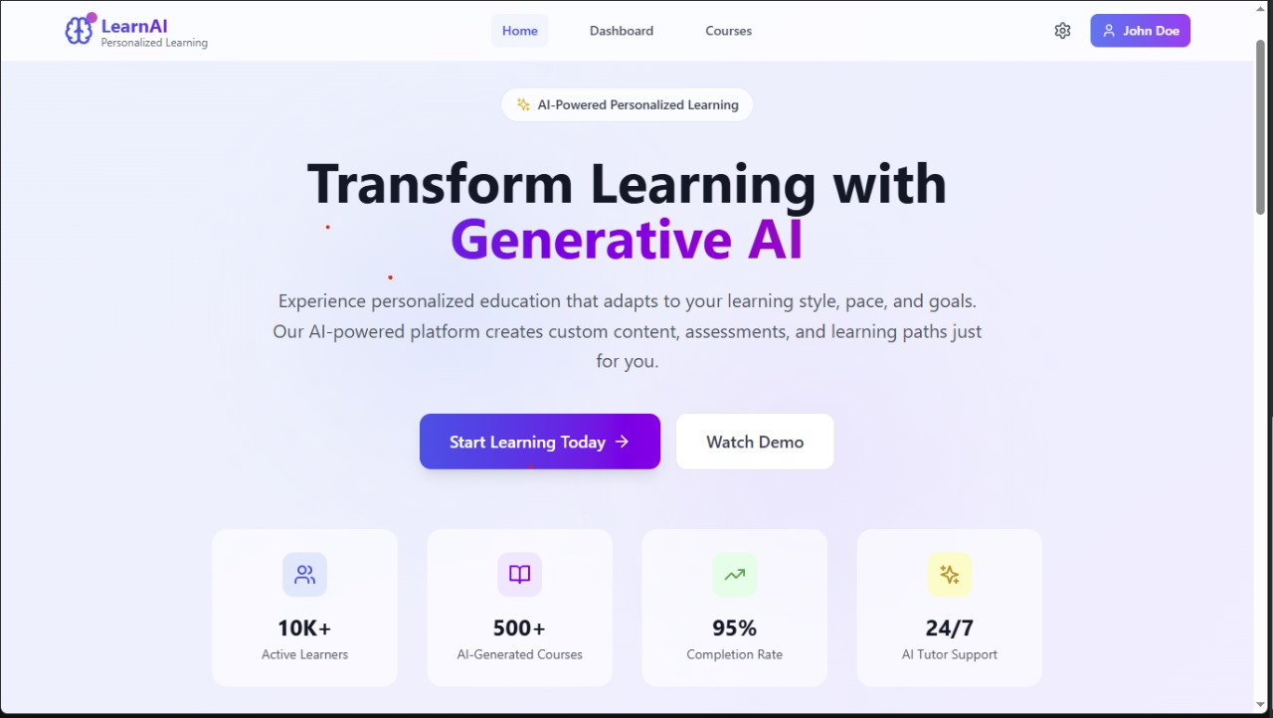Phase 5: Vector Database Integration
Objectives Completed:
- Configured Pinecone vector database
- Implemented document embedding
- Created semantic search functionality
- Added retrieval mechanisms
Key Deliverables:
- Document embedding pipeline
- Semantic search capabilities
- Policy document management
Phase 6: Machine Learning Features
Objectives Completed:
- Implemented KPI forecasting
- Added anomaly detection
- Created predictive models
- Built data analysis pipelines
Key Deliverables:
- Forecasting algorithms
- Anomaly detection system
- Data visualization components
Phase 7: Report Generation
Objectives Completed:
- AI-powered report generation
- Custom prompt engineering
- Multi-format output support
- Dynamic content creation
Key Deliverables:
- Automated report generation
- Customizable report templates
- Export functionality
Phase 8: Integration and Testing
Objectives Completed:
- End-to-end system integration
- Comprehensive testing suite
- Performance optimization
- User acceptance testing
Key Deliverables:
- Fully integrated system
- Testing documentation
- Performance benchmarks

7. Setup and Installation
7.1 Prerequisites
- Python 3.8 or higher
- IBM Cloud account with Watsonx access
- Pinecone account and API key
- Git for version control
7.2 Installation Steps
Step 1: Environment Setup
# Clone the repository
git clone <repository-url>
cd sustainable-smart-city-assistant

# Create virtual environment
python -m venv venv

# Activate virtual environment
# Windows:
venv\Scripts\activate
Step 2: Dependency Installation
# Install required packages
pip install -r requirements.txt
Step 3: Configuration
- Create .env file with your API credentials
- Configure IBM Watsonx settings
- Set up Pinecone vector database
- Verify configurations using test scripts
Step 4: Application Launch
# Method 1: Use the launcher (recommended)
python run_app.py
# Method 2: Manual startup
# Terminal 1 - Backend:
uvicorn app.main:app --reload --host 127.0.0.1 --port 8000

# Terminal 2 - Frontend:
streamlit run frontend/smart_dashboard.py --server.port 8501
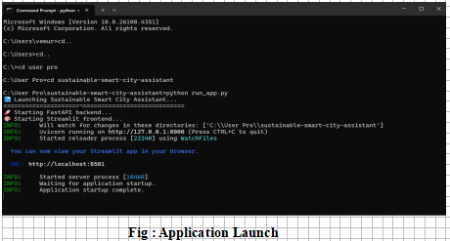
8. Features and Functionality
8.1 Dashboard Overview
Description: Central hub displaying key city sustainability metrics Components:
- Real-time KPI cards (Air Quality, Water Usage, Energy Consumption, Waste Recycling)
- City selection dropdown for comparative analysis
- Interactive metric visualization
- Trend indicators and alerts
8.2 Chat Assistant
Description: AI-powered conversational interface for city-related queries Capabilities:
- Natural language processing using Granite LLM
- Context-aware responses about urban sustainability
- Multi-turn conversation support
- Real-time response generation
8.3 Citizen Feedback System
Description: Community engagement platform for citizen input Features:
- Categorized feedback submission
- Contact information collection
- Feedback tracking and management
- Response analytics and reporting
8.4 Eco-Tips Generator
Description: Personalized environmental recommendations Functionality:
- Topic-based tip generation
- AI-powered content creation
- Actionable sustainability advice
- Category-specific recommendations
8.5 Policy Document Search
Description: Semantic search through policy documents Technology:
- Vector-based document retrieval
- Natural language query processing
- Relevance ranking and scoring
- Document summarization capabilities
8.6 KPI Analysis and Forecasting
Description: Predictive analytics for city metrics Features:
- Historical data analysis
- Trend forecasting algorithms
- Anomaly detection systems
- Performance benchmarking
8.7 Report Generation
Description: Automated sustainability reporting Capabilities:
- AI-generated comprehensive reports
- Custom prompt engineering
- Multi-format output support
- Data-driven insights and recommendations

9. API Documentation
9.1 Chat Endpoints
POST /api/chat/ask
Description: Submit chat queries to AI assistant
Request Body: {"message": "string"}
Response: {"response": "string", "status": "string"}
9.2 Feedback Endpoints
POST /api/feedback/submit
Description: Submit citizen feedback
Request Body: {
"name": "string",
"category": "string",
"message": "string",
"email": "string"
}
Response: {"message": "string", "status": "string", "feedback_id": "string"}

GET /api/feedback/list
Description: Retrieve all feedback entries
Response: {"feedback": [...], "count": number}
9.3 Eco-Tips Endpoints
GET /api/eco-tips/generate?topic={topic}
Description: Generate eco-friendly tips for specified topic
Parameters: topic (string) - The topic for which to generate tips
Response: {"tips": "string", "topic": "string", "status": "string"}
9.4 Policy Endpoints
POST /api/policy/summarize
Description: Summarize uploaded policy documents
Request Body: {"text": "string"}
Response: {"summary": "string", "status": "string"}

POST /api/vector/search
Description: Semantic search through policy documents
Request Body: {"query": "string", "top_k": number}
Response: {"results": [...], "status": "string"}
9.5 KPI Endpoints
POST /api/kpi/upload
Description: Upload KPI data for analysis
Request Body: Form data with CSV file
Response: {"message": "string", "analysis": {...}, "status": "string"}

POST /api/kpi/forecast
Description: Generate forecasting for KPI data
Request Body: {"data": [...], "periods": number}
Response: {"forecast": [...], "metrics": {...}, "status": "string"}

10. Screenshots and Results
10.1 Dashboard Interface
The main dashboard provides an intuitive overview of city sustainability metrics:
- KPI Cards: Visually appealing metric displays with trend indicators
- City Selection: Dropdown for comparative analysis across different cities
- Real-time Updates: Dynamic data refresh capabilities
- Responsive Design: Optimized for desktop and mobile viewing

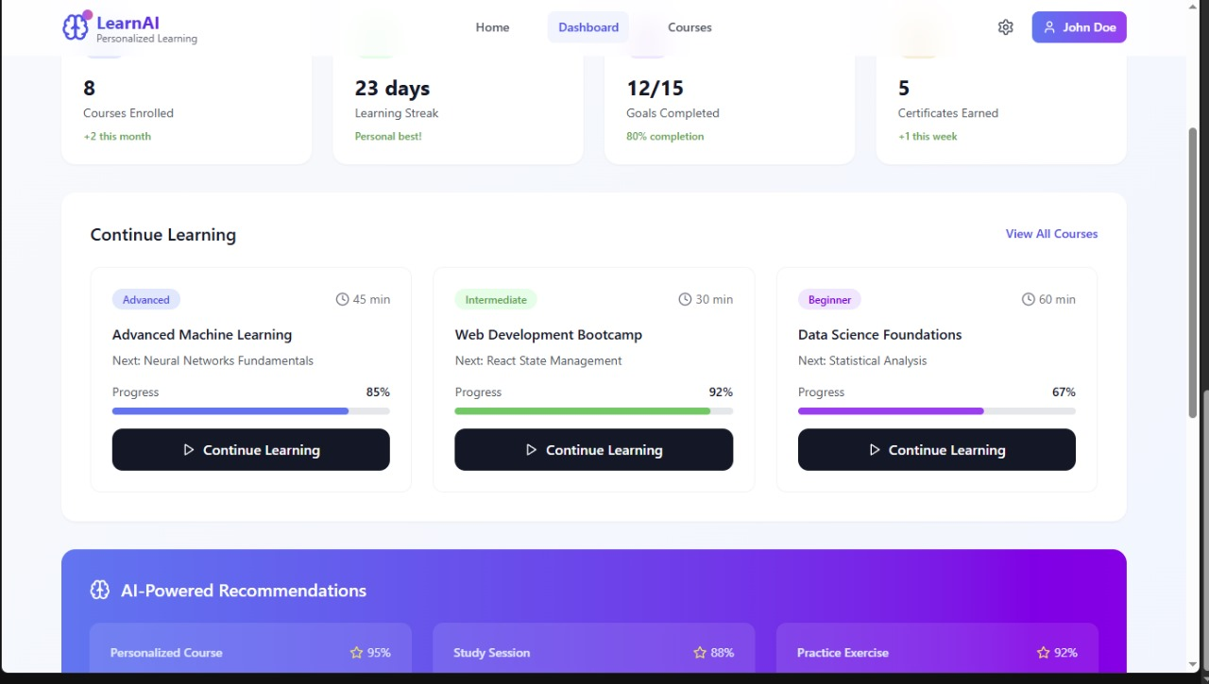10.2 Chat Assistant Interface
The conversational AI interface demonstrates:
- Natural Language Processing: Advanced query understanding
- Context Awareness: Maintains conversation context
- Professional Responses: Well-formatted, informative answers
- Interactive Design: User-friendly chat bubble interface
fg:dash board
10.3 Feedback System
The citizen engagement platform shows:
- Form Validation: Comprehensive input validation
- Category Management: Organized feedback classification
- Submission Tracking: Unique ID generation for follow-up
- Success Notifications: Clear confirmation messages
10.4 Policy Search Results
The semantic search functionality displays:
- Relevance Ranking: Results ordered by semantic similarity
- Document Snippets: Contextual preview of relevant content
- Search Accuracy: High precision in document retrieval
- User Experience: Fast and intuitive search interface
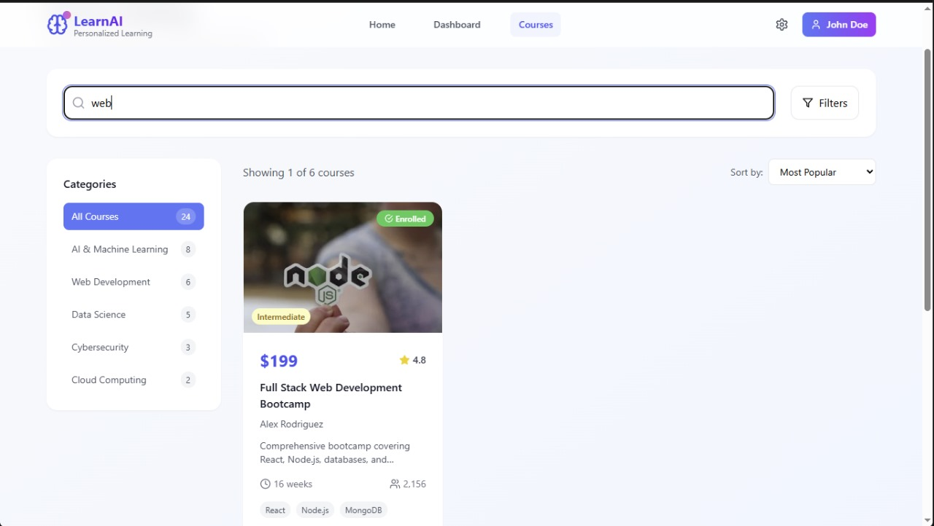
Fig: Policy Summarizer and Searcher

11. Challenges and Solutions
11.1 Technical Challenges
Challenge 1: API Integration Complexity
Problem: Integrating multiple external APIs (IBM Watsonx, Pinecone) with different authentication methods and response formats.
Solution:
- Created wrapper services for each API
- Implemented consistent error handling
- Added fallback mechanisms for service failures
- Standardized response formats across all services
Challenge 2: Real-time Data Processing
Problem: Handling real-time data updates and maintaining synchronization between frontend and backend.
Solution:
- Implemented asynchronous request handling
- Added caching mechanisms for frequently accessed data
- Created efficient data serialization processes
- Optimized API response times
Challenge 3: Vector Database Management
Problem: Managing document embeddings and ensuring efficient semantic search performance.
Solution:
- Optimized embedding generation pipeline
- Implemented batch processing for large documents
- Added index management utilities
- Created automated cleanup processes
11.2 Design Challenges
Challenge 1: User Experience Consistency
Problem: Maintaining consistent UI/UX across different components and pages.
Solution:
- Developed reusable component library
- Implemented standardized styling guidelines
- Created consistent navigation patterns
- Added responsive design principles
Challenge 2: Performance Optimization
Problem: Ensuring fast loading times and smooth user interactions.
Solution:
- Implemented lazy loading for components
- Optimized API calls and caching
- Minimized redundant operations
- Added loading indicators for better UX

12. Future Enhancements
12.1 Planned Features
- Mobile Application: Native mobile app for iOS and Android
- Real-time Notifications: Push notifications for critical alerts
- Advanced Analytics: Machine learning-powered insights dashboard
- Multi-language Support: Internationalization and localization
- Integration APIs: Third-party service integrations (weather, traffic, etc.)
12.2 Scalability Improvements
- Database Migration: Transition to PostgreSQL/MongoDB for production
- Microservices Architecture: Further decomposition of services
- Load Balancing: Implement horizontal scaling capabilities
- Caching Layer: Redis implementation for improved performance
- Container Deployment: Docker and Kubernetes deployment
12.3 AI Enhancements
- Custom Model Training: Fine-tuned models for specific city domains
- Multi-modal AI: Image and document processing capabilities
- Predictive Analytics: Advanced forecasting algorithms
- Natural Language Understanding: Enhanced query processing
- Automated Insights: Proactive recommendations and alerts

13. Conclusion
13.1 Project Success Metrics
The Sustainable Smart City Assistant project has successfully achieved its primary objectives:
- Functional AI Integration: Successfully integrated IBM Watsonx Granite LLM for intelligent responses
- Comprehensive Feature Set: Delivered all 8 planned features with full functionality
- User-Friendly Interface: Created an intuitive and responsive web application
- Scalable Architecture: Implemented modular design for future enhancements
- Technical Excellence: Maintained high code quality and documentation standards
13.2 Key Achievements
- Advanced AI Integration: Seamless integration of enterprise-grade AI services
- Full-Stack Development: Complete end-to-end application development
- Modern Technology Stack: Utilization of cutting-edge frameworks and tools
- Professional UI/UX: High-quality user interface with custom styling
- Comprehensive Documentation: Detailed technical and user documentation
13.3 Impact and Value
The project demonstrates significant value in:
- Urban Governance: Providing intelligent tools for city management
- Citizen Engagement: Facilitating better communication between citizens and government
- Environmental Sustainability: Promoting eco-friendly practices and awareness
- Data-Driven Decision Making: Enabling evidence-based policy decisions
- Technology Innovation: Showcasing practical AI applications in public sector
13.4 Lessons Learned
- API Integration Complexity: The importance of robust error handling and fallback mechanisms
- User Experience Design: The critical role of intuitive interface design in adoption
- Modular Architecture: The benefits of well-structured, maintainable code organization
- Documentation Importance: The value of comprehensive documentation for project sustainability
- Continuous Testing: The necessity of thorough testing throughout development cycles
13.5 Final Recommendations
For organizations looking to implement similar AI-powered city management solutions:
- Start with Clear Objectives: Define specific use cases and success metrics
- Invest in Quality APIs: Choose reliable, enterprise-grade AI services
- Prioritize User Experience: Focus on intuitive design and user feedback
- Plan for Scalability: Design architecture with future growth in mind
- Maintain Documentation: Keep comprehensive technical and user documentation
- Implement Monitoring: Add comprehensive logging and monitoring systems
- Plan for Security: Implement robust security measures from the beginning
The Sustainable Smart City Assistant represents a successful implementation of AI technology in urban governance, demonstrating the potential for intelligent systems to enhance city management and citizen engagement while promoting environmental sustainability.
VideoLink:https://drive.google.com/file/d/12aaVdYrTLaZPoC28UpsgBD-Q9pvNNEyq/view?usp=drive_link
https://drive.google.com/file/d/15GlAiq5mFC8eXKUYHqxnLij6f7QcuYAM/view?usp=drivesdk

